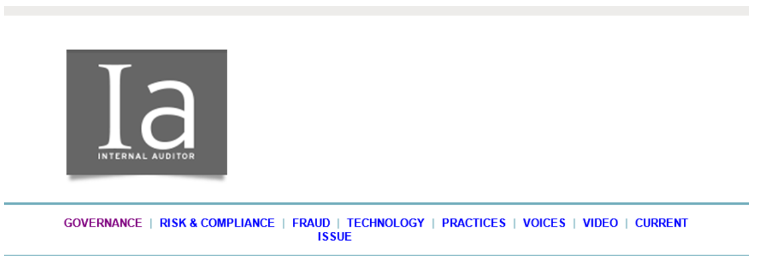
IIA Finland has partnered with IIA Global to give you access to Internal Auditor magazine which provides valuable perspectives and robust content on the most relevant issues affecting internal auditors worldwide. We are pleased to inform you that the October issue is now available for your access. If you have any questions related to this service, please contact IIA Finland.
Emerging Leaders 2018
By Russell A. Jackson
The October edition leads with the annual recognition of 15 up-and-coming internal audit practitioners from around the world who have made a difference in their organizations and stand out among their peers. These high-performing, innovative internal auditors are raising the bar for today’s young audit professionals and emerging as the thought leaders of tomorrow.
Read more.
Powering Productivity
By Shannon Steffee
The average person opens approximately nine apps a day, according to a report on consumer mobile usage. We wanted to know which ones internal auditors are using. Internal Auditor asked its Emerging Leaders to tell us about the apps they rely on for work and play and which stand out as their favorites. Answers varied, but several picks floated to the top. Read more.

PRACTICES
Ten Tips to Manage your Career
By Richard J. Anderson
An active approach to career management can lead to more long-term success. Mastering 10 skills can help internal auditors better position themselves to take advantage of opportunities and enable them to prosper in today’s work environment.
Read more.

Agents of Improvement
By James E. Schulien
Internal audit’s stakeholders say consulting on business process improvements is the top area where auditors can provide advice. Internal audit can adopt several practices in approaching these types of high-impact projects. Read more.​
RISK & COMPLIANCE
In Any Kind of Weather
By Paul Sobel
One year after COSO issued its updated ERM framework, many internal audit functions are working to apply the new framework to help their organizations weather risks that are on the horizon. Through its assurance and advice, internal audit can help the organization apply the framework’s principles. Read more.

GOVERNANCE

A Clear Picture
By Gregory Grocholski
Internal audit cannot afford to sit back and let others dictate its role. CAEs must make it a priority to educate executive management, audit committees, or other governing bodies on the conditions where internal audit can provide high-quality assurance, advice, and insight. Read more.

Aspiring Toward Leadership
Internal Auditor’s Emerging Leaders know what it takes to succeed. Watch several of this year’s honorees share their advice on climbing the professional ladder.
Watch video.
Stakeholders Have the Last Word on Whether Internal Audit Adds Value
By Richard Chambers
A while back, an IIA task force was formed to explore stakeholder expectations and determine what internal auditors should deliver in the way of value. Its recommendations described a "value proposition" for internal auditing based on three core concepts: assurance, insight, and objectivity. Read more.

